Group 12 Proposal: Members: Kade Rivers, Chris Hicks, Fatina Hamadi, and Kevin Carney

1. What is your dataset and why?
   1. Dataset for Renewable Energy - <https://www.kaggle.com/datasets/girumwondemagegn/dataset-for-renewable-energy-systems/data>
   2. Why? Renewable Energy: Data-Driven Decision-Making: Datasets allow for evidence-based analysis, which is crucial for informed energy policy and investment decision-making.
      1. **Sustainability Goals:** Renewable energy is central to achieving global sustainability goals.
      2. **Technological Innovation:** The field rapidly evolves with new technologies and innovations that can be tracked and analyzed through datasets.
      3. **Economic Impact:** Renewable energy has significant financial implications, including job creation, industry growth, and changes in energy markets.
      4. **Environmental Impact:** The primary driver for renewable energy is its potential to reduce environmental impact, particularly greenhouse gas emissions.
   3. For question number 3 on our guided principles we would like to use <https://www.iea.org/reports/renewables-2023/executive-summary> to help guide our analysis in addition to our dataset to show future projections.
2. Three research guiding questions:
   1. Which renewable energy sources have the greatest energy production vs consumption. Based on storage efficiency vs production what is the most efficient renewable energy
   2. Which sources have the greatest financial incentives vs initial investment. Job creation can be mentioned as a supplement to the data, and jobs can be the focus of regression.
   3. What is the most utilized source of renewable energy at this time. Datapoints for reference would be, number of appearances on dataset, grid integration level. Reference additional data set that can show projections on future implementation.
3. Inspiration:
   1. Renewable Energy and Weather Conditions
   2. Global Energy Consumption & Renewable Generation
   3. Global Data on Sustainable Energy (2000 – 2020)
   4. https://www.iea.org/reports/renewables-2023/executive-summary
4. Possible Visualizations: (*At least 5)*
   1. Line Graph showing consumption vs production for energy types
   2. Violin plot for each type of energy for consumption vs production
   3. Bar Graph showing financial incentives vs initial investment
   4. Bubble chart that shows incentives vs investment vs common funding types
   5. Stacked bar chart showing total jobs created per energy type
   6. Scatter plot that shows each individual entry for energy and the jobs they create
   7. Pie chart showing market share of each type of energy
5. What are you regressing?
   1. Initial Investment vs Jobs Created
   2. Funding sources vs Financial Incentives
6. Color Palette
   1. 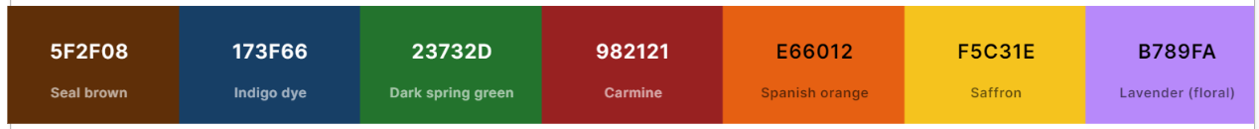
   2. Each energy type will have its own color which we will use for all applicable visualizations. Other colors will be implemented as needed to represent relationships. But we will try and use these colors when possible.
7. Roles and Responsibilities
   1. Data Cleaning - All of us work together.
   2. One or two people for question 1 - Kevin / Fatina
   3. One or two people for question 2 - Kade
   4. One or two people for question 3 - Chris
   5. Regression - Kevin
   6. Slides - All
   7. Written portion of presentation - Fatina
8. Formatting and filetype
   1. Slides in PowerPoint or Mural
   2. PDF that’s got our analysis
   3. Jupyter Notebook that have codes